**Mater Dei College**

**Student Portal**

A thesis submitted in partial fulfillment of the requirements for the degree of

**Bachelor of Science**

in

**Information Technology**

by:

Zeshyrou B. Anober

Mae Ann Salutan

Marilyn Cosadio

Sharmine Babatuan

Under the guidance of :

**Mr. Benjie Lenteria**

College of Computer Information and Communication Technology

Mater Dei College

Tubigon, Bohol, Philippines.

Executive Summary

Online education is important now and will be even more important to Mater Dei College success and the community success as the area population grows, the economy declines and the high cost of transportation continue to increase.

Group 1 proposes to set-up MDC’s commitment to online Student Portal support by developing and launching an innovative 24/7 campus web portal. The portal will be user friendly, one-step website where students can find information. All that is needed is a student ID, personal pin and internet connection.

The portal is a Datatel product, called Active Campus Portal. It will interact with school calendars, events, updates and announcement, student information including subject enrolled with a printable grade for current subject enrolled. The portal will be wide collaboration which will be strategically demonstrated to students. Once the portal is live and active, students will see the features and the admin will have an easy way to communicate and distribute information.

Since mobile usage is now rapidly increasing the portal has a responsive design, means that it will and always be accessible in any devices.

List of Tables

Table Title Page

1. Functional Requirements ---------------------------------------------------- 7
2. Non-Functional Requirements ---------------------------------------------------- 7
3. Use Case 001 ---------------------------------------------------- 8
4. Use Case 002 ---------------------------------------------------- 8
5. Use Case 003 ---------------------------------------------------- 8
6. Use Case 004 ---------------------------------------------------- 9
7. Use Case 005 ---------------------------------------------------- 9
8. Use Case 006 ---------------------------------------------------- 9
9. Use Case 007 ---------------------------------------------------- 10
10. Use Case 008 ---------------------------------------------------- 10
11. Use Case 009 ---------------------------------------------------- 10
12. Use Case 010 ---------------------------------------------------- 11
13. Use Case 011 ---------------------------------------------------- 11
14. Use Case 012 ---------------------------------------------------- 11
15. Use Case 013 ---------------------------------------------------- 12

List of Figures

Figure Title Page

1. Foreign Related System --------------------------------------------------------------- 3
2. Local Related System --------------------------------------------------------------- 4
3. Log In 1 Form --------------------------------------------------------------- 12
4. Log In 2 Form --------------------------------------------------------------- 13
5. Student Home Page --------------------------------------------------------------- 13
6. Student Subject Enrolled --------------------------------------------------------------- 14
7. School Year Event Calendar --------------------------------------------------------------- 14
8. Student Faq’s --------------------------------------------------------------- 15
9. Student Feedbacks --------------------------------------------------------------- 15
10. Admin Home Page --------------------------------------------------------------- 16
11. Admin Accounts --------------------------------------------------------------- 16
12. Admin Students --------------------------------------------------------------- 17
13. Admin Subjects --------------------------------------------------------------- 17
14. Admin Announcement --------------------------------------------------------------- 18
15. Admin Verification --------------------------------------------------------------- 18
16. Database Tables --------------------------------------------------------------- 19
17. Implementation Plan Infrastructure ------------------------------------------------- 20
18. Relevant Source Code(Web.php) ------------------------------------------------- 21
19. Relevant Source Code (Controller.php) ------------------------------------------------- 21
20. Relevant Source Code (Welcome.php) ------------------------------------------------- 22
21. Sample Output/Input Reports ------------------------------------------------- 22
22. General Data Flow Diagram ------------------------------------------------- 25
23. Mobile Size --------------------------------------------------------------- 27
24. Tablet Size --------------------------------------------------------------- 27
25. Desktop Size --------------------------------------------------------------- 28
26. Sample Generated Output (Grade.pdf) ------------------------------------------------- 29
27. Sample Generated Output (Verification.pdf) -------------------------------------------- 30

Table of Contents

Title ------------------------------------ I

Executive Summary ------------------------------------ II

List of Tables ------------------------------------ III

List of Figures ------------------------------------ IV

Introduction ------------------------------------ 1

* 1. Project Context ------------------------------------ 1
  2. Purpose And Description ------------------------------------ 1
  3. Objectives ------------------------------------ 1
  4. Scope and Limitations ------------------------------------ 2

Review of Related Literature/Systems ------------------------------------ 3

Technical Background ------------------------------------ 5

Methodology, Results and Discussion ------------------------------------ 7

* 1. Requirements Analysis ------------------------------------ 7
  2. Requirements Documentation ------------------------------------ 8
  3. Design of Software and Testing ------------------------------------ 12
  4. Implementation Plan ------------------------------------ 20

Recommendations ------------------------------------- 20

Appendices may include the following -------------------------------------- 21

* 1. Relevant Source Code -------------------------------------- 21
  2. Sample input/output/reports -------------------------------------- 22
  3. Users Guide -------------------------------------- 23
  4. Process/Data/Information Flow -------------------------------------- 26
  5. Screen Layouts -------------------------------------- 27
  6. Sample Generated Outputs -------------------------------------- 28

Chapter 1 - Introduction

* 1. Project Context

MDC Student Portal System is a web system that provides the functions and features to authenticate the users and provide them with an easy, intuitive, personalized and user friendly interface for facilitating access to information and services that are of primary relevance and interest to users. It contains an admin who can upload details of students. Students can then log in using their student id as a username and a personal pin that can be configure during the registration. A portal may include avatar, a student can upload an image of them to be recognized by the admin. It is nothing but a portal which thinks students as the main target users to provide single place and private place of a student. Through a single interface but in customized form like posting, updating or deleting an announcements or events and in monitoring of the subjects they are already taken. Also the system is capable of generating pdf means that a student can download their grade based on the current subject strictly by semester.

* 1. Purpose and Description

Description

MDC Student Portal is an online gateway where a student can log-in to access important program information. The portal contain information on basic details of a student, subjects enrolled, subjects currently enrolled with printable grade and updates from the school.

Purpose

The main purpose of the system is to introduce to the school the beauty of functionality of using cloud storage on helping them to manage student record, to lessen their works ,to guide the students of the happenings in school, provides security and back-up for the student information wherever there is a data loss.

* 1. Objectives

General objectives

* The project aimed to provide an online gateway, a Student Portal.
* To provide an online access that supported the application of student and admin.

Specific Objectives

* To lessen the workloads of the registrar personnel during releasing of grades.
* To minimize the time and effort of the student during releasing of grades.
* To develop an accurate and easiest way of Student Portal of Mater Dei College by accessing it into the internet.
* To guide the students for the activities in school.
* It improved the privacy, user-friendliness and enable convenient access to the different kind of information.
* It had an effective way of providing information anytime and anywhere .

1.4 Scope and Limitation

Scope

* The Student Portal System is a web based application that covers the major processes in getting the grades by semester for students, guiding students about the activities of the school, awareness of student about their subjects enrolled and have an access to their basic information.
* Administrator have a total access to the system, generating a verifications that would be used by the student for creating their account in the portal. To post an updates and announcements, to create an event for the school year calendar.
* The system gives further information about the school and the system itself.

Limitations

* The system does not cover the paying of fees.
* The system does not provide a live chat function.
* The portal does not support enrollment.
* The portal does generate grade by semester only.
* A student must have only one account.
* A student can only view and download their present subject enrolled.
* A student can only view events, updates and announcements,school and system faq’s.

Chapter 2 - Review of Related Literature/Systems

Foreign

Chicago Public School Student Portal

A unique, web based tool that allows students to view their grades and attendance online.

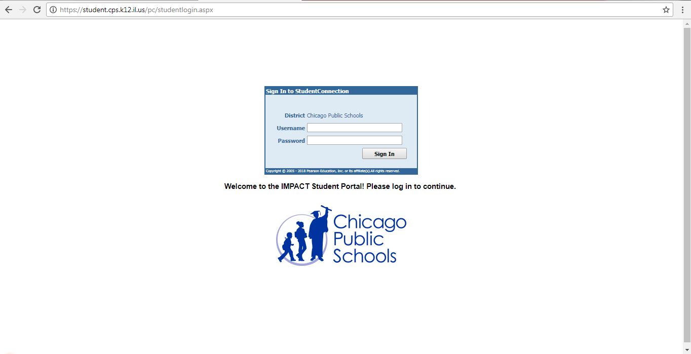**Figure 1**  - Foreign Related System

Differences:

MDC Student portal is available for all the students but not with class by class. The students can get their grades based by all the subjects he/she enrolled in the semester not by subject for a certain class. Also the portal doesn’t cover triggers once the grades are fully uploaded by the admin there will be a post that the grade is available. Our calendar is quite different because it depends on the school events by year.

Advantages:

MDC Student portal is available 24/7 and has a real time functionality to view what is the posted activity or announcements .Also the grade is not only by viewing but you can download it and print for the hard copy.

Local

Student Portal UE(University of the East)

Is a gateway for online student information, lectures, discussions, resources and other exclusive to UE students.

**Figure 2** – Local Related System

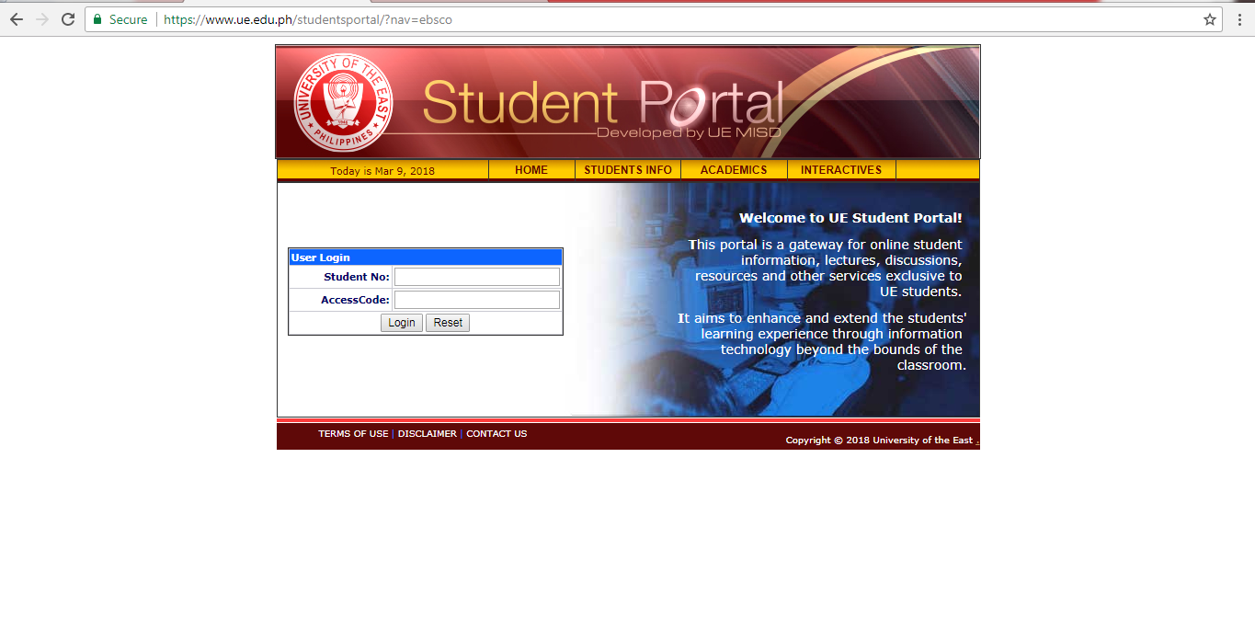

Differences:

MDC student portal is also for student online information but it doesn’t cover the discussion forum for a student and teacher for a certain subject. It also doesn’t support for the recommended resources for the certain lesson or subject. But UE student portal can’t generate grades and post an updates or announcements from school.

Advantages:

MDC student portal has the advantages of less paper works for the printing of grades and less hassle for the registrar office. Also have a real time updates from school and can view student grade anytime, anywhere.

Chapter 3 - Technical Background

Hardware

For laptops and computer

* Minimum 5 GB HDD space
* At least Intel Pentium processor
* At least 2 GB RAM

For tablets and mobile

* At least a touch screen

Software

* Operating system

Recommended (“Windows” ) at least a version of 7 above.

* PHP

PHP is a script language and interpreter that is freely available and used primarily on Linux Web servers. PHP, originally derived from **Personal Home Page** Tools, now stands for PHP: Hypertext Preprocessor, which the PHP FAQ describes as a "recursive acronym." At least a 7.0 version above.

* Javascript

JQuery is a [JavaScript](https://techterms.com/definition/javascript) library that allows web developers to add extra functionality to their websites. It is [open source](https://techterms.com/definition/opensource) and provided for free under the MIT license. In recent years, jQuery has become the most popular JavaScript library used in [web development](https://techterms.com/definition/web_development).

* CSS

CSS stands for **Cascading Style Sheets**. CSS describes how HTML elements are to be displayed on screen, paper, or in other media. CSS saves a lot of work. It can control the layout of multiple web pages all at once. External stylesheets are stored in CSS files.

* Laravel

Is a free, open-source PHP web framework, created by Taylor Otwell and intended for the development of web applications following the model–view–controller (MVC) architectural pattern.

* Composer

- is an application-level package manager for the PHP programming language that provides a standard format for managing dependencies of PHP software and required libraries.

* Node

- is an open source development platform for executing **JavaScript** code server-side.**Node**.**js** is intended to run on a dedicated HTTP server and to employ a single thread with one process at a time. **Node**.**js** applications are event-based and run asynchronously.

* XAMPP

- stands for Cross-Platform (X), Apache (A), MariaDB (M), PHP (P) and Perl (P). It is a simple, lightweight Apache distribution that makes it extremely easy for developers to create a local web server for testing and deployment purposes.

* Web Browsers (recommended)

- Google chrome

Chapter 4 - Methodology, Results and Discussion

* 1. Requirements Analysis

|  |  |
| --- | --- |
| **MDC Student Portal** | |
| Requirements Summary | |
|  |  |
| **Table 1** – Functional Requirements |  |
| **Functional Requirements** |  |
| **Use Cases** |  |
| USE_CASE_001 | The software provides Registration Form for student users. |
| USE_CASE_002 | The software provides Login Form for all users. |
| USE_CASE_003 | The software provides different dashboard for all users. |
| USE_CASE_004 | The software is capable of generating PDF. |
| USE_CASE_005 | The software provides updates and announcement. |
| USE_CASE_006 | The software provides school year event calendar. |
| USE_CASE_007 | The software provides faq's of the system and school. |
| USE_CASE_008 | The software provides avatar for the user. |
| USE_CASE_009 | The software is capable of changing user password. |
| USE_CASE_010 | The software is capable of generating random string for verification. |
| USE_CASE_011 | The software provides search for student. |
| USE_CASE_012 | The software provides search for subject. |
| USE_CASE_013 | The software provides feedback. |

**Table 2** – Non-Functional Requirements

|  |  |
| --- | --- |
| **Non-Functional Requirements** |  |
| **Function No.** | **Non-Functional Requirements** |
| NON_FUNC-001 | OS Support: Windows XP, Windows Vista, Windows 7 above,APK(android) |
| NON_FUNC-002 | Browser Support: Mozilla, Chrome |
| NON_FUNC-003 | Minimum Hardware Requirements,Android 4.1 up,Apple IOS |

1.2 Requirements Documentation

|  |
| --- |
| **MDC Student Portal** |
| Requirements Specification |

**Table 3** – Use_case_001

|  |  |  |  |
| --- | --- | --- | --- |
| **Use Case** | **USE_CASE_001** |  |  |
| **Description** | The software provides Registration Form for student users. |  |  |
| **Requirement No.** | **Description** | | **Limitation** |
| REQT_001 | A student can register the portal by using the verification given by the registrar. | | Only one account for a student. |
| REQT_002 | A verification can only used once. | |  |
| REQT_003 | A student is required to fill the credentials. | |  |
| REQT_004 | A toast notification is visible if the student is successfully registered. | |  |

**Table 4** – Use_case_002

|  |  |  |  |  |
| --- | --- | --- | --- | --- |
| **Use Case** | **USE_CASE_002** |  |  | |
|  |  |  |  | |
| **Description** | The software provides Login Form for all users. |  |  | |
| **Requirement No.** | **Description** | **Limitation** | |
| REQT_001 | Must have an account. |  | |
| REQT_002 | User is required to fill the fields. |  | |
| REQT_003 | A toast notification is visible if the user is successfully logged in. |  | |

**Table 5** – Use_case_003

|  |  |  |  |
| --- | --- | --- | --- |
| **Use Case** | **USE_CASE_003** |  |  |
| **Description** | The software provides different dashboard for all users. |  |  |
| **Requirement No.** | **Description** | | **Limitation** |
| REQT_001 | Must have an account to have a dashboard. | |  |
| REQT_002 | Grade and user profile are only the difference in the dashboard. | |  |

**Table 6** – Use_case_004

|  |  |  |  |
| --- | --- | --- | --- |
| **Use Case** | **USE_CASE_004** |  | |
| **Description** | The software is capable of generating PDF. | | |
| **Requirement No.** | **Description** | | **Limitations** |
| REQT_004_01 | Must have an account. | |  |
| REQT_002_02 | Admin user can generate pdf for the verification and the file name is "verification.pdf". | |  |
| REQT_004_03 | Student user can generate pdf for the grade and file name is "grade.pdf". | | Student can only generate grade by semester. |
| REQT_004_04 | A toast notification with the content of "verfication downloaded" for the admin and "grade" for the student when it generated successfully. | |  |

**Table 7** – Use_case_005

|  |  |  |  |  |  |  |  |
| --- | --- | --- | --- | --- | --- | --- | --- |
| **Use Case** | | **USE_CASE_005** | | |  | |  |
| **Description** | | The software provides updates and announcement. | | |  | |  |
| **Requirement No.** | | **Description** | | | **Limitation** | | |
| REQT_001 | | Must have an account to view. | | |  | | |
| REQT_002 | | Announcement and updates can only posted by the admin user. | | |  | | |
| REQT_003 | | Student user can only view the posted updates and announcement. | | | Only for view, can't comment or share. | | |
|  | |  | | |  | | |
| **Table 8** – Use_case_006 | |  | | |  | | |
| **Use Case** | | **USE_CASE_006** |  | |  | |
| **Description** | | The software provides school year event calendar. |  | |  | |
| **Requirement No.** | | **Description** | | | **Limitation** | |
| REQT_001 | | Must have an account to view. | | |  | |
| REQT_002 | | School year calendar events can only posted by the admin user. | | |  | |
| REQT_003 | | Student user can only view the posted events. | | | Only for view, can't comment or share. | |

**Table 9** – Use_case_007

|  |  |  |  |  |
| --- | --- | --- | --- | --- |
| **Use Case** | | **USE_CASE_007** |  |  |
| **Description** | | The software provides faq's of the system and school. |  |  |
| **Requirement No.** | | **Description** | | **Limitation** |
| REQT_001 | | Must have an account to view. | |  |
| REQT_002 | | Faq’s section is only html for viewing. | | Can’t be updated. |
|  | |  | |  |
| **Table 10** – Use_case_008 | |  | |  |
| **Use Case** | **USE_CASE_008** |  |  | |
| **Description** | The software provides avatar for the user. |  |  | |
| **Requirement No.** | **Description** | | **Limitation** | |
| REQT_001 | Must have an account and logged. | |  | |
| REQT_002 | Choose picture for the avatar in "setting"icon. | | Only one picture. | |
| REQT_003 | A toast notification with the content of "avatar is successfully set" when the action is successful. | |  | |

**Table 11** – Use_case_009

|  |  |  |  |
| --- | --- | --- | --- |
| **Use Case** | **USE_CASE_009** |  |  |
| **Description** | The software is capable of changing user password.. |  |  |
| **Requirement No.** | **Description** | | **Limitation** |
| REQT_001 | Must have an account and logged. | |  |
| REQT_002 | Must enter the current password to proceed. | |  |
| REQT_003 | Required to fill the fields. | |  |
| REQT_004 | A toast notification with the content of "Successfully change password" when the action is successful. | |  |

**Table 12** – Use_case_010

|  |  |  |  |
| --- | --- | --- | --- |
| **Use Case** | **USE_CASE_010** |  |  |
| **Description** | The software is capable of generating random string for verification. |  |  |
| **Requirement No.** | **Description** | | **Limitation** |
| REQT_001 | A admin user is logged. | | Student user. |
| REQT_002 | Required to fill the field . | | Only ten digit of random string is generated. |
| REQT_003 | A toast notification with the content of "Successfully verification generated" when the action is successful. | | . |

**Table 13** – Use_case_011

|  |  |  |  |
| --- | --- | --- | --- |
| **Use Case** | **USE_CASE_011** |  |  |
| **Description** | The software provides search for student. |  |  |
| **Requirement No.** | **Description** | | **Limitation** |
| REQT_001 | A admin user is logged. | | Student user. |
| REQT_002 | Required to fill the field to search. | |  |
| REQT_003 | Can only for viewing and updating. | | Can’t delete student. |
| **Table 14** – Use_case_012 |  | |  |
| **Use Case** | **USE_CASE_012** |  |  |
| **Description** | The software provides search for subject. |  |  |
| **Requirement No.** | **Description** | | **Limitation** |
| REQT_001 | A admin user is logged. | | Student user. |
| REQT_002 | Required to fill the field to search. | |  |
| REQT_003 | Can only for viewing and updating. | | Can’t delete subject. |

**Table 15** – Use_case_013

|  |  |  |  |
| --- | --- | --- | --- |
| **Use Case** | **USE_CASE_013** |  |  |
| **Description** | The software provides feedback.. |  |  |
| **Requirement No.** | **Description** | | **Limitation** |
| REQT_001 | A student user is logged. | |  |
| REQT_002 | Required to fill the field . | |  |
| REQT_003 | A toast notification with the content of "Thank you for the feedback" when the action is successful. | |  |

1.3 Design of Software and Testing

Front-end layout plan of the system.

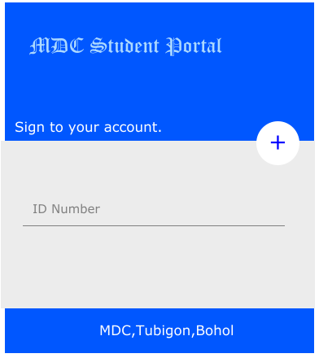 **Figure 3 -** Log In 1 Form

Figure 3 is the layout for log-in form that has a required field to proceed .The button on the top-right with the plus sign in the middle indicates to register a new user.

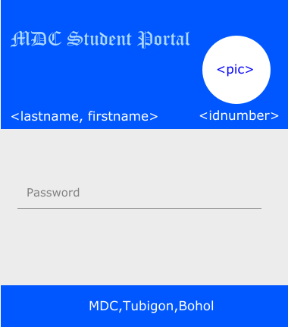 **Figure 4 -** Log In 2 Form

Figure 4 is the layout for log-in form that has a required field to proceed.

Student User

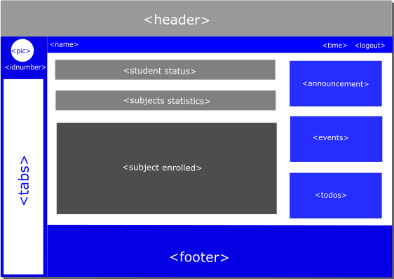 **Figure 5 -** Student Home Page

Figure 5 is the layout for dashboard for student user where the most of the information is viewed especially the current subject with grade.

**Figure 6** - Student Subjects Enrolled

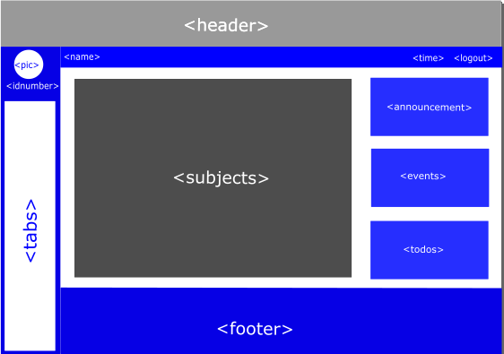

Figure 6 is the layout for the subject already taken of a student with a status of failed or passed.

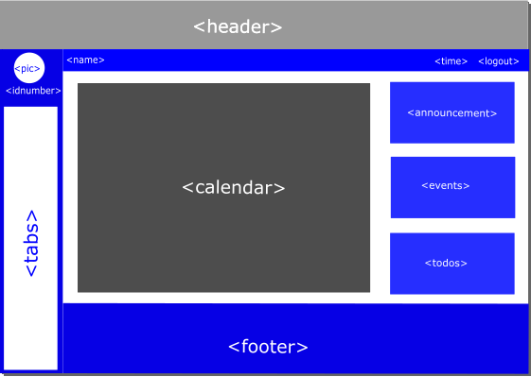 **Figure 7** - Student School Event Calendar

Figure 7 is the layout for the viewing of the whole school year event.

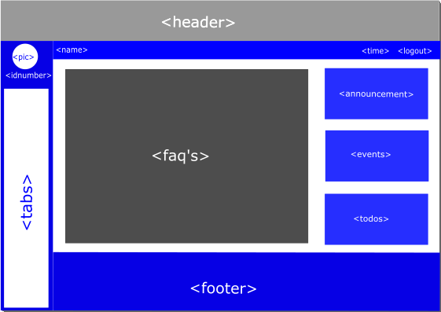 **Figure 8** - Student Faq’s

Figure 8 is the layout for the frequently ask and questions about the system and school.

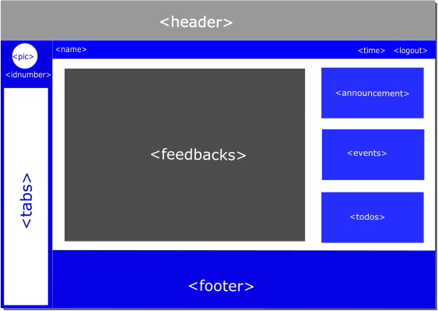 **Figure 9** - Student Feedback

Figure 9 is the layout for the feedback of the student about the system and it requires to fill the fields.

Admin User

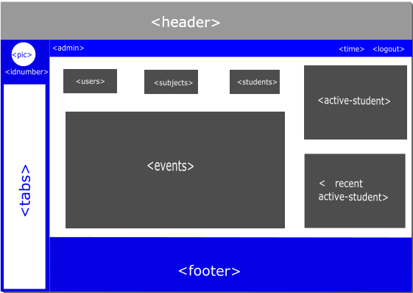 **Figure 10** - Admin Home Page

Figure 10 is the layout for dashboard for admin user.

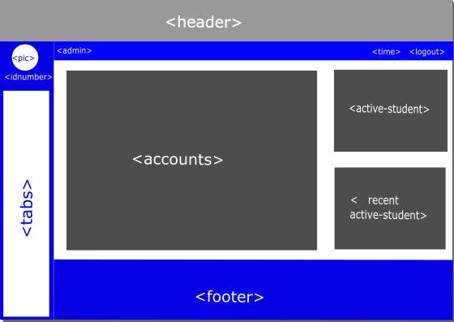 **Figure 11** - Admin Accounts

Figure 11 is the layout where all of the accounts will be viewed.

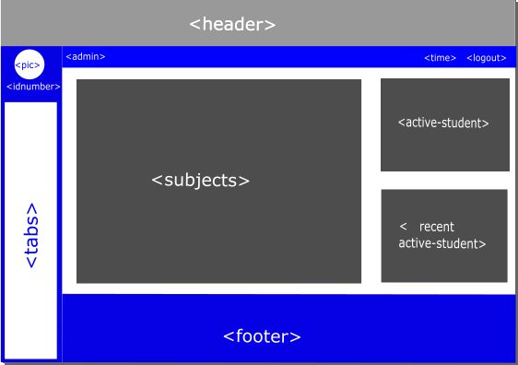 **Figure 12** - Admin Subjects

Figure 12 is the layout where all of the subjects will be viewed with the corresponding students.

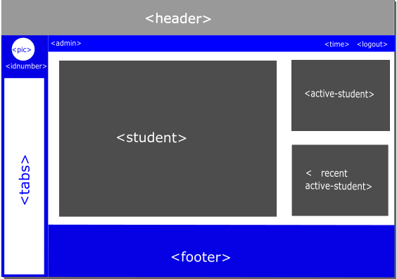 **Figure 13** - Admin Students

Figure 13 is the layout where all of the students will be viewed with their basic information.

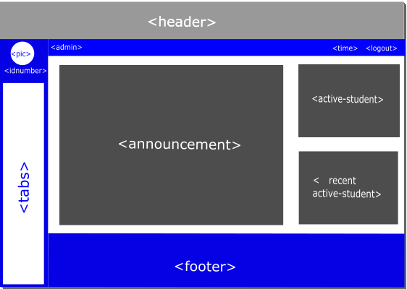 **Figure 14** - Admin Announcements

Figure 14 is the layout of the announcement for the admin user.

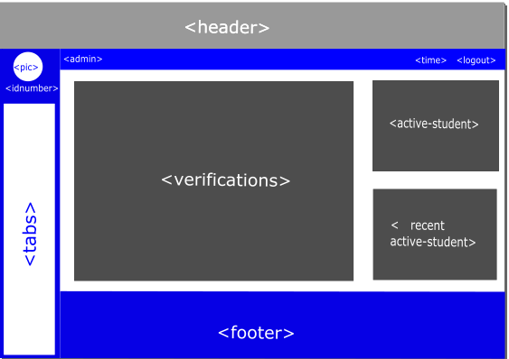 **Figure 15** - Admin Verifications

Figure 15 is the layout of the verification for the admin user.

Back-end database design of the system.

**Figure 16 –** Database Tables

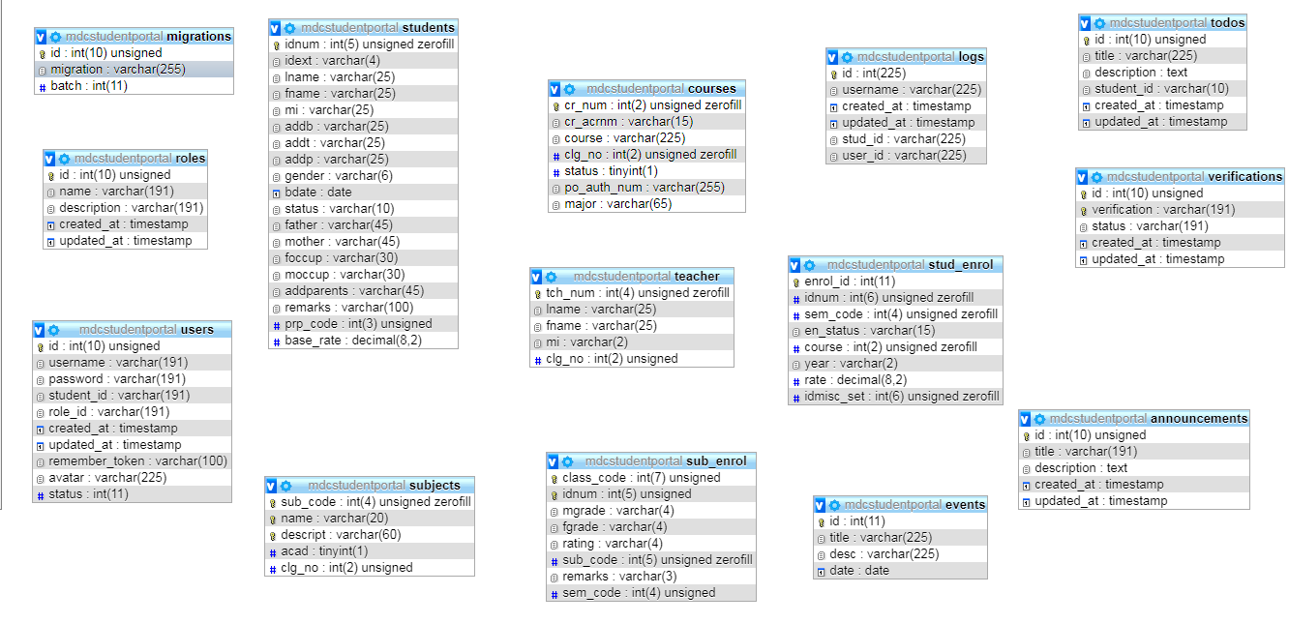

* 1. Implementation Plan (Infrastructure/Development)

Since the MDC Student Portal is a web based application it will be uploaded to the internet and can be accessible through by the internet.

**Figure 17** – Implementation Plan Infrastructure

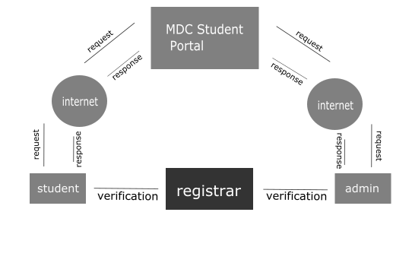

Verification is generated by the admin from the system but it will be given manually to the student after their enrollment for some security reasons. Verification can only be used once.

Chapter 5 – Recommendation

The research resulted to be a more efficient and faster experience for the school to release information.

Online process is a growing trend nowadays since we are surrounded by technology. As a growing college and yet to become university someday this research could help for the future. May the features of this system today is not yet achieve the ultimate functions of Student Portal but as we all know that the big things today is a small things yesterday.

For the future of the system, when the school has server it may include the online enrollment system and tuition payment.

Chapter 6 - Appendices may include the following

* 1. Relevant Source Code

Web.php

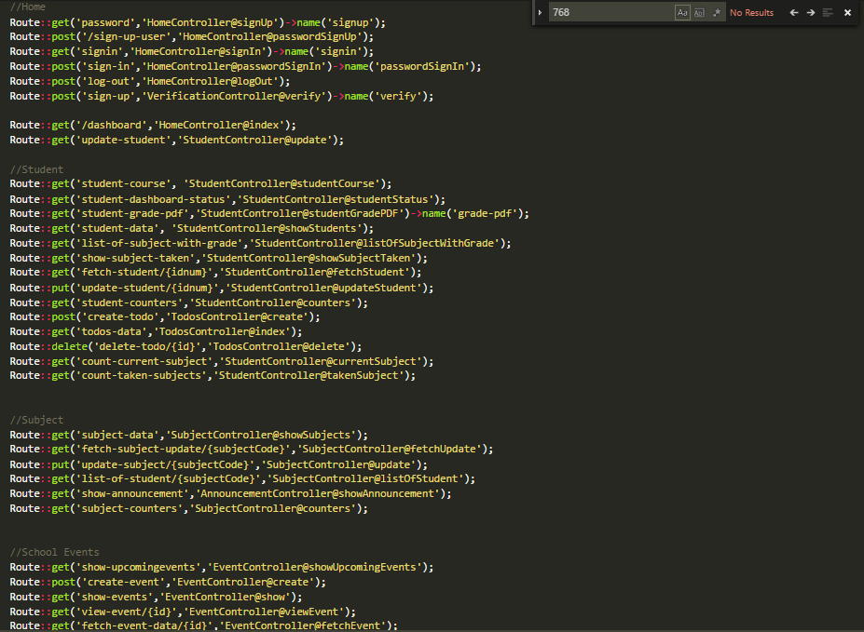**Figure 18** – Relevant Source Code (Web.php)

Controller.php

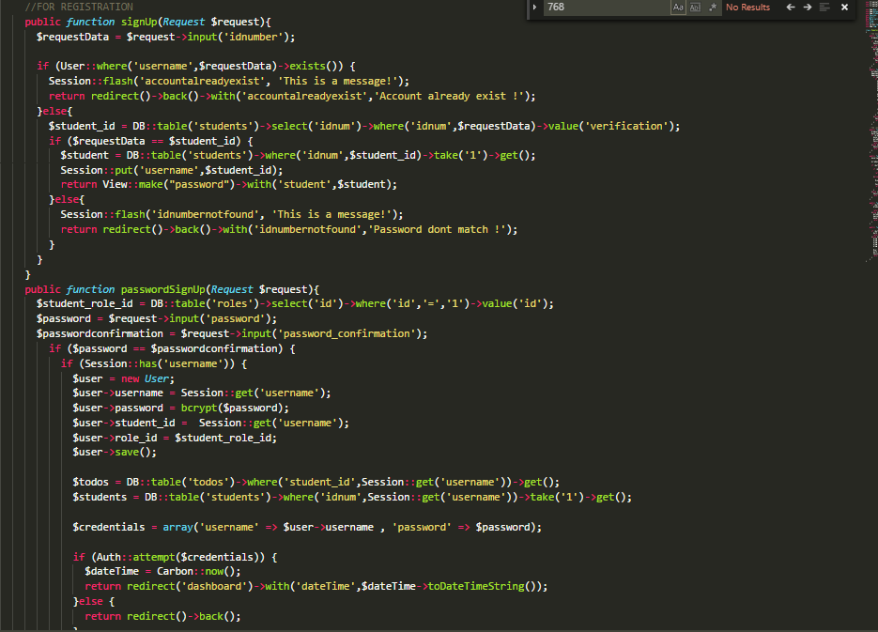**Figure 19** – Relevant Source Code(Controller.php)

Welcome.php

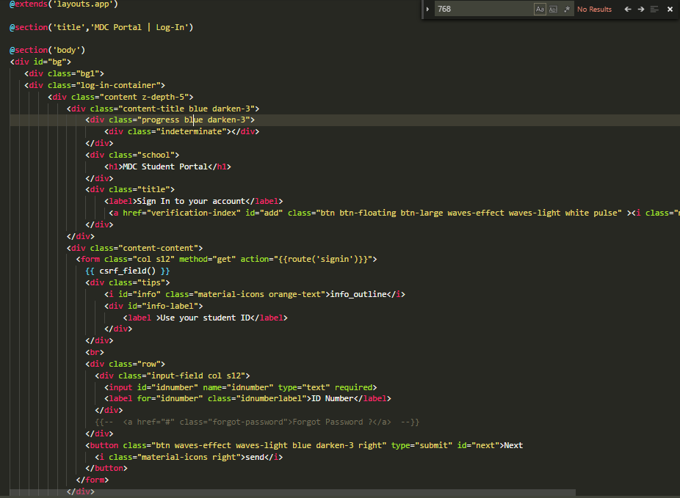**Figure 20 –** Relevant Source Code(welcome.php)

* 1. Sample input/output/reports

**Figure 21** - Sample of Input/Output

Input

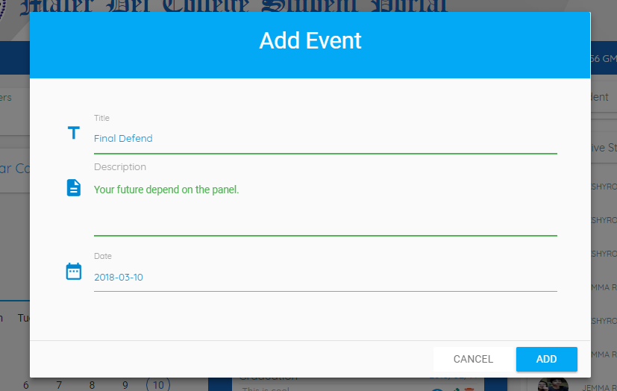

Ouput

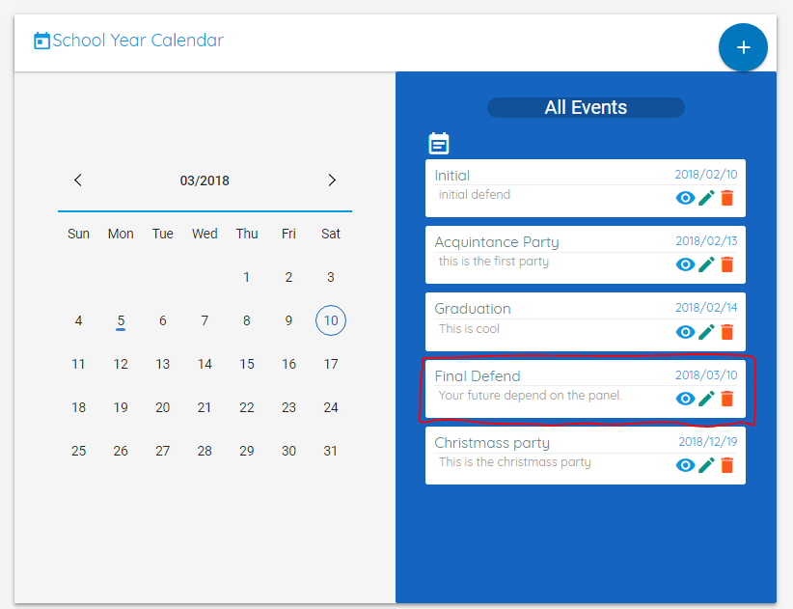

* 1. Users Guide

Admin User

For uploading the data to database:

1. An admin must log in to the hosting site.
2. Import the exported sql file into the dabase hosting site from the registrar office.
3. Successfully uploaded the data to database.

For adding, updating and deleting an updates and announcements:

1. An admin must logged in the portal.
2. Left side of the dashboard the tabs are located just click announcement tab.
3. “Add new” button is visible after clicking the announcement tab.
4. Click the button then a modal is visible and fill the fields the click “Go” button.
5. A toast notification is visible with the content of “Announcement created” when the action is successful.
6. Bottom side of the announcement container actions are visible.
7. Pressing the eye icon in the actions returned a modal and the announcement details are viewed.
8. Pressing the pencil icon returned a modal and the announcement details are viewed but this time the fields are editable.
9. Press the “Go” button then a toast notification is visible with the content of “Announcement Updated” when the action is successful.
10. Pressing the trash icon in the actions returned a confirmation modal.
11. Press “Ok ” button then a toast notification is visible with the content of “Announcement deleted” when the action is successful.

For adding, updating and deleting an events :

1. An admin must logged in the portal.
2. In the dashboard events are located.
3. Press circular button top-right.
4. A modal is visible and fill the fields the click “Go” button.
5. A toast notification is visible with the content of “Event created” when the action is successful.
6. Right side of the events container actions are visible.
7. Pressing the eye icon in the actions returned a modal and the event details are viewed.
8. Pressing the pencil icon returned a modal and the event details are viewed but this time the fields are editable.
9. Press the “Go” button then a toast notification is visible with the content of “Event Updated” when the action is successful.
10. Pressing the trash icon in the actions returned a confirmation modal.
11. Press “Ok ” button then a toast notification is visible with the content of “Event deleted” when the action is successful.

For changing the account password:

1. An admin must logged in the portal.
2. Left side of the dashboard the tabs are located just click account tab.
3. Click the account tab and the search field is now visible.
4. Use student id for the search field then click “Go” button.
5. A searched student is visible below now click the pencil button.
6. After clicking the button a modal is visible with the user, a new password field s now available.
7. Fill the field and click “Go” button then a toast notification is visible with the content of “Account Updated” when the action is successful.

For generating verification and download as a pdf:

1. An admin is required to logged in the portal.
2. Left side of the dashboard the tabs are located just click verification tab.
3. To generate a verification that composer of ten digit random string is to fill the field left side of the button “generate” it required to be a number.
4. When the field is already fill click the “generate” button.
5. A toast notification is visible with the content of “Verification generated” when the action is successful.
6. To download the verification just click the circular button located below of the “generate” button and it will automatically downloaded for you.
7. A toast notification is visible with the content of “Verification downloaded” when the action is successful.

Student User

For registration:

1. Once the student is enrolled, a verification is given from the registrar personel.
2. A student must input the verification for them to proceed.
3. After the verification, a student must enter their student ID to be used as a username.
4. Once the student success to input their student ID they need to input their personal pin and confirm it.
5. After the registration it will be redirect to the student dashboard.

For logging in:

1. A student is required enter the username where is set by the Student ID.
2. A student is required enter their personal pin.

For downloading grade:

1. A user must log in first.
2. In the dashboard the subject currently enrolled is viewed as a table and there is a button above.
3. The button have a function to generate the table into pdf document redirectly downloaded.

For changing the avatar:

1. A user must log in.
2. Top-left in the dashboard there is an user avatar that is clickable and will bring you in the user profile tab.
3. In the user tab, you can view setting icon that is also clickable and will pop up a box modal.
4. In the box modal there is a select file button and also clickable that will allow you to choose your desired avatar.
5. After you choose your desired avatar it will preview in the box modal and the press the go button to configure.
   1. Process/Data/Information Flow

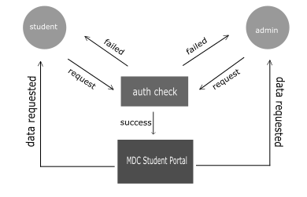**Figure 22** - General Data Flow Diagram

* 1. Screen Layouts

Mobile

**Figure 23** – Mobile Size

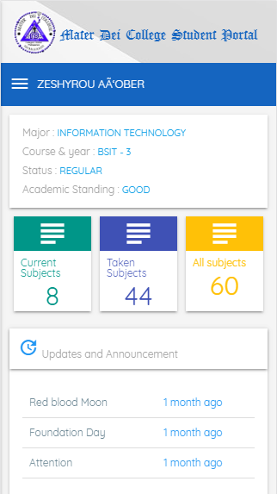

Tablet

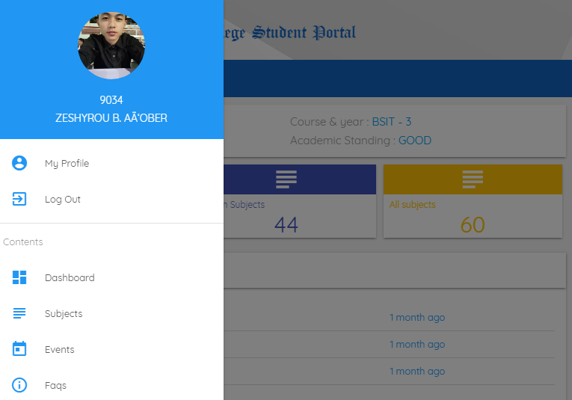 **Figure 24** – Tablet Size

Desktop

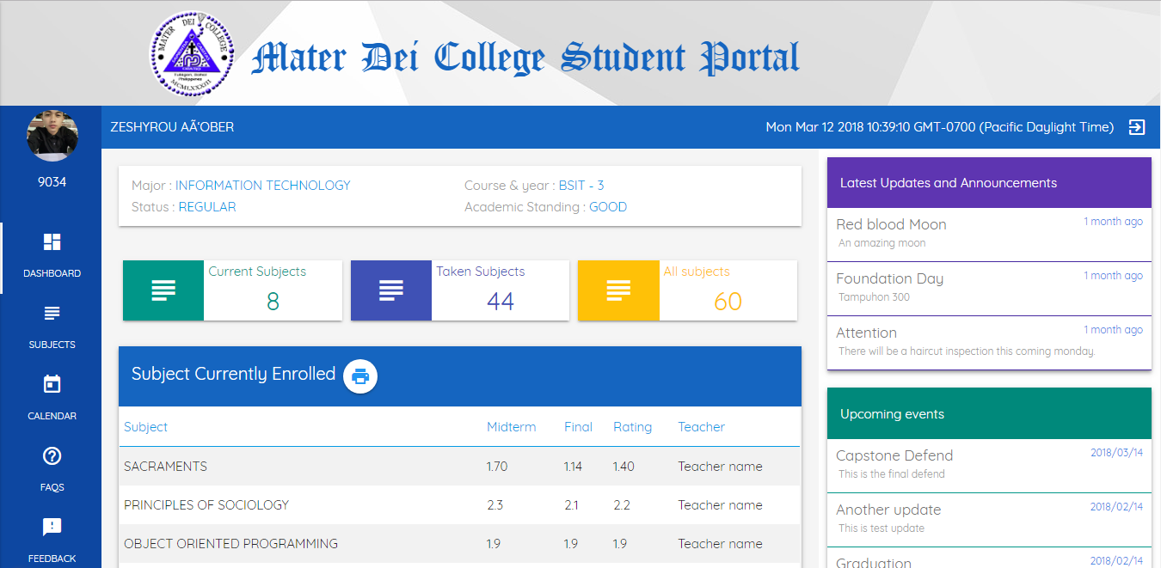**Figure 24** – Desktop Size

* 1. Sample Generated Outputs

Grade.pdf

**Figure 25** – Sample Generated Output Grade

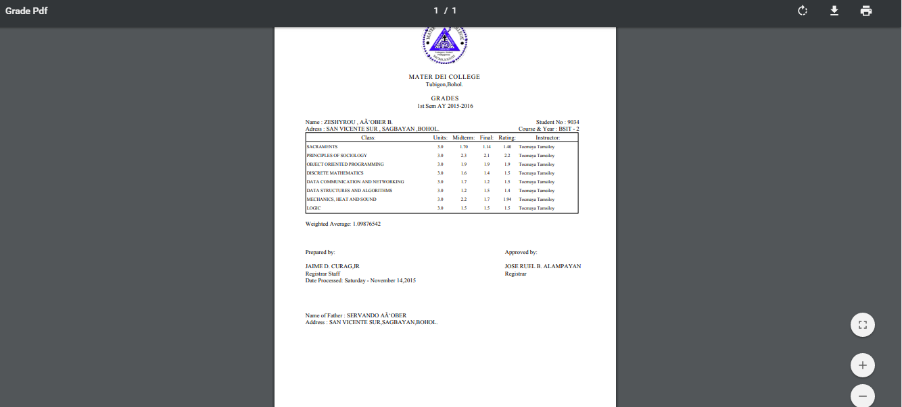

Verification.pdf

**Figure 26** – Sample Generated Output Verification

